## **μSMET**

μSMET is an autonomous, electrically-driven robotic mobility platform that can carry US Army light infantry personnel and payload quickly and quietly to and from conflict areas and rally points anywhere from narrow trails to urban alleys. Such a platform can be used in a number of last-mile applications in the battlefield. The robot also enables some unique force protection or offensive capabilities in the theater.

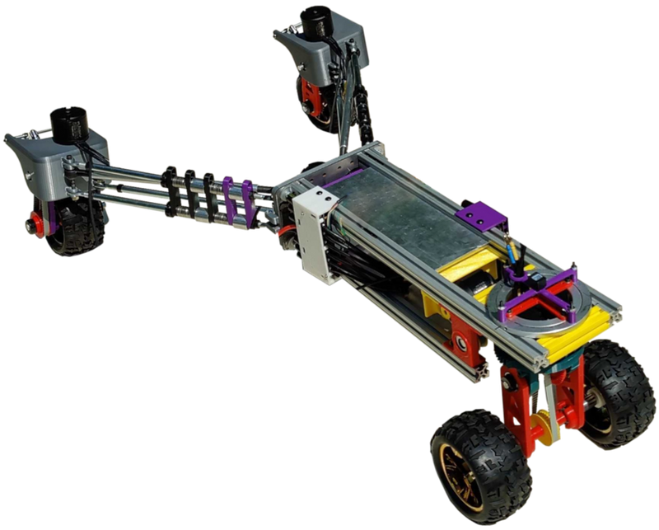

Link to Demonstration Video: <https://www.m-visioninc.com/our-technology-1>